**PROJECT REPORT ON TRAVEL TRAX TOURS**

I INTRODUCTION:

* 1. OVERVIEW:

Accounting plays a essential role in any business organization as it helps to record all transactions and analysis the financial status of the business at the end of the financial year. In this project, we prepare the financial reports of Travel Trax Tours through zohobooks. With the use of zohobooks,  we did the  transactions  such as set up organisation profile, item creation, vendors creation, customers creation, to make a purchase order, to receive the sales order, to create a bank account, to create a petty cash, payment made to vendors through bank account and petty cash, received the payment from the customers through bank account and petty cash, filling the GST, creation of bills and invoice, making the journal entry and finally we get the reports of profit and loss account and balance sheet.

* 1. PURPOSES
* The purposes of the project is to accumulate the report of financial information about the performance financial position and cash flow of a business.
* To measure the process of a company financial statement overtime and see how it changes.

II PROBLEM DEFINITION AND DESIGN THINKING;

2.1 Empathy Map

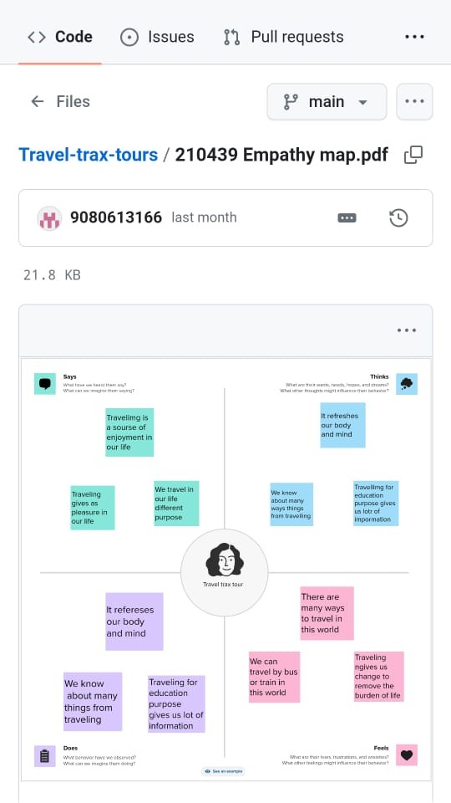

2.2 BrainStorming Map

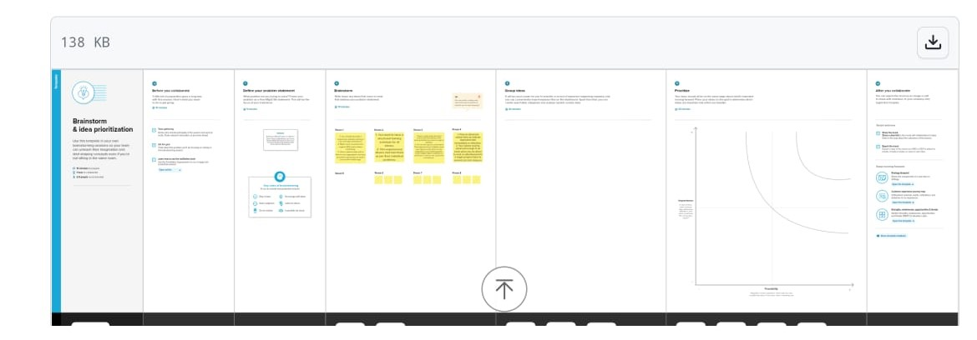

III RESULT

Profit &Loss

Balance sheet

Account Receivables

Account Payable

Bank Transaction

G.S.T 3B Summary

Journal Report

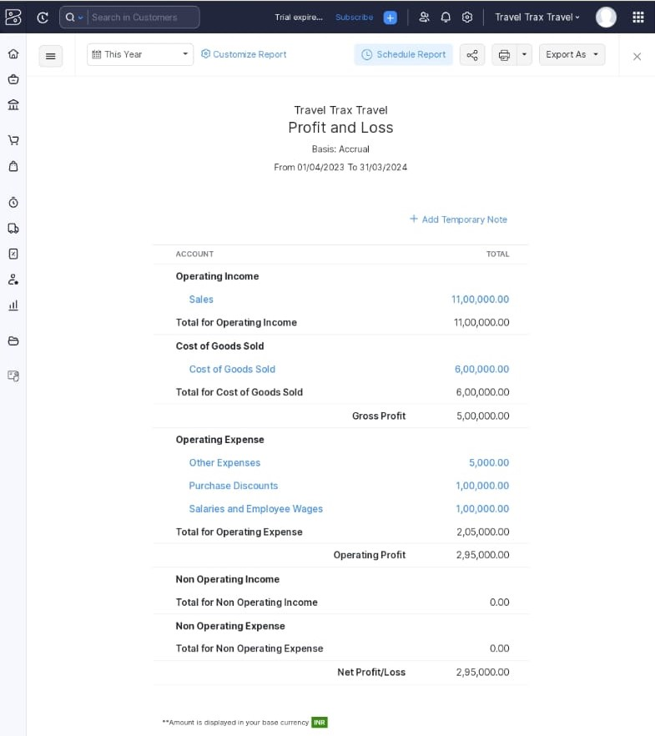

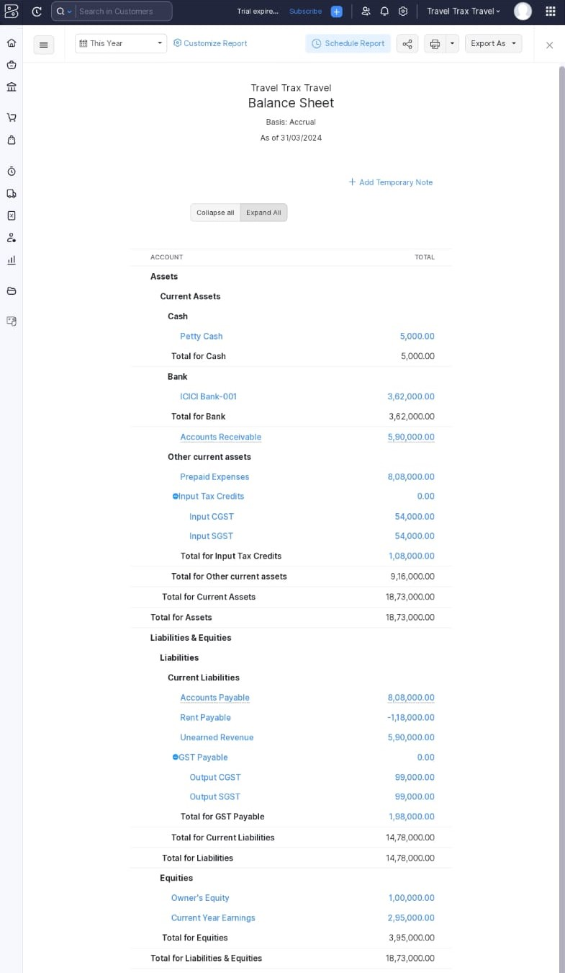

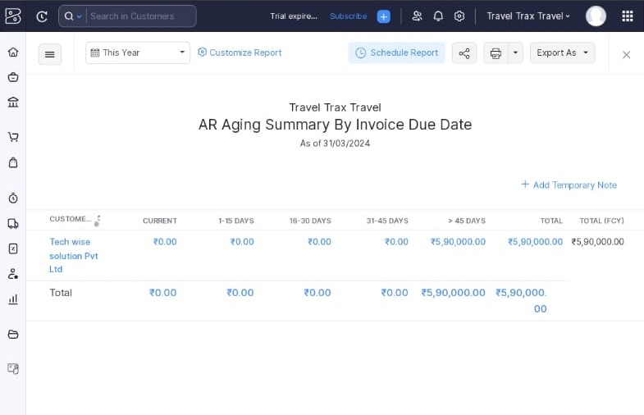

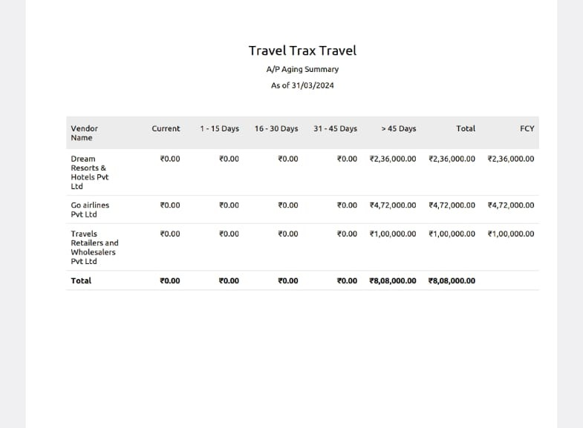

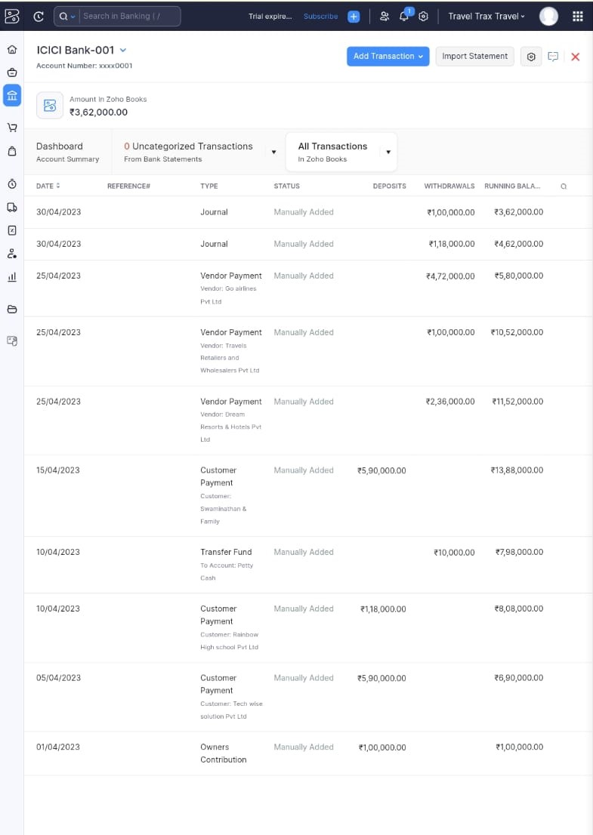

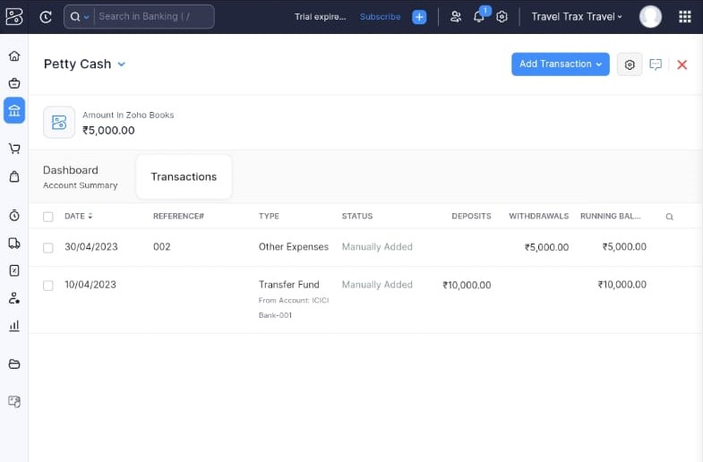

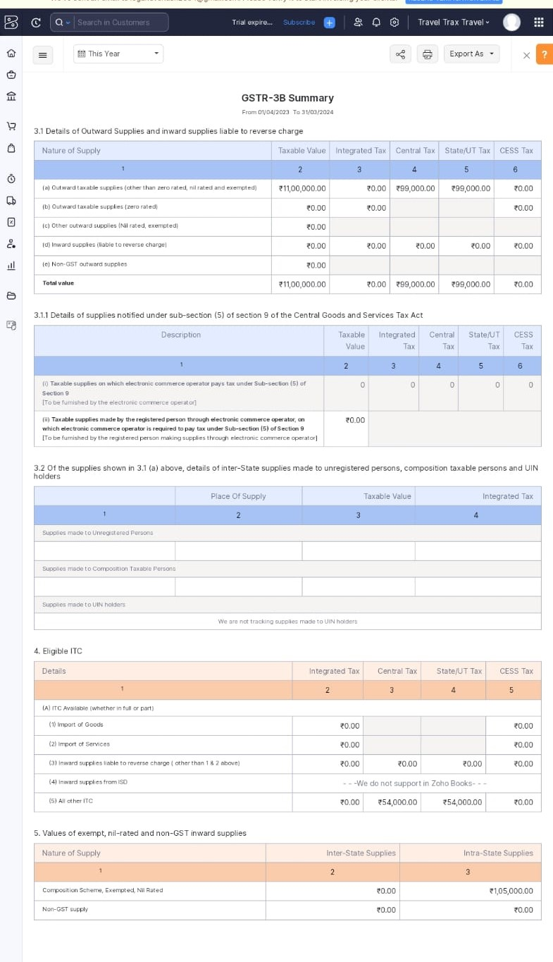

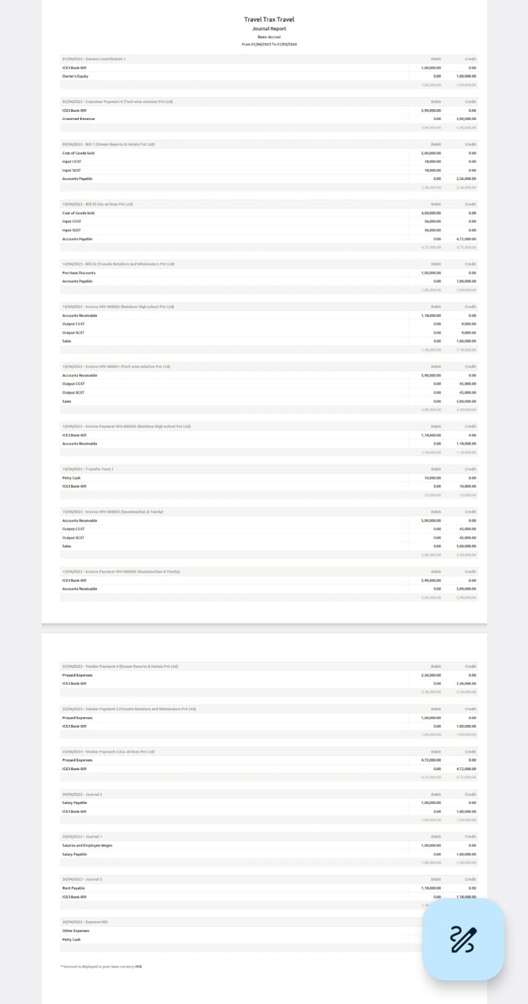

IV CONCLUSION

From this project it is clearly indicates that a summarized a financial statement which supply on overview of the financial activities of the business among a period such as;

* Asset : 18,73,000
* Liabilities: 18,73,000
* Bank balance : 3,62,000
* Cash balance : 5000
* Trade payables : 8,08,000
* Trade Receivables : 5,90,000
* Cost of book solds : 6,00,000
* GST payable : 8,08,000
* GST Receivable : 12,98,000
* Operating Income : 11,00,000
* Operating Expenses : 2,05,000

During the year as well as information about its financial position on a specific date.

* As we have seen in this chapter tourism is a complex system that is built up of industry sector including transportation and travel services.
* And because of this large scope tourism of development requires participation educational institution etc.

V Future scope:

* This project will be helps to business plan for the future by providing insights into how much money they have and how much they will need.
* It also track the performance of a business and helps make a crucial decision about in future.